
ARYABHATTA COLLEGE,UNIVERSITY OF DELHI

DATA MINING
PRACTICAL FILE

Submitted to: Dr. Sonal Linda
Name : Ronit
College RollNo : CSC/20/1
University RollNo : 20059570001
Course : B.Sc Hons Computer Science
Year : III
Semester : VI

INDEX

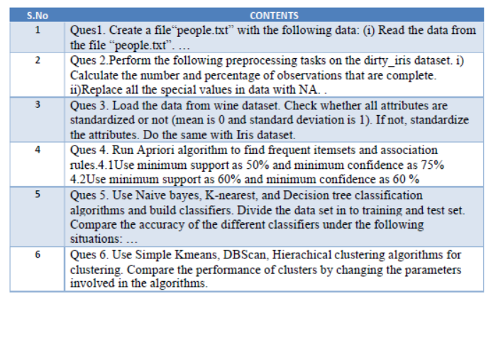

Ques1. Create a file"people.txt" with the following data:
(i) Read the data from the file "people.txt".
(ii) Create a ruleset E that contain rules to check for the following conditions:
- The age should be in the range 0-150.
- The age should be greater than years married.
- The status should be married or single or widowed.
- If age is less than 18 the age group should be child, if age is between 18 and 65. The agegroup should be adult, if age is more than 65 the age group should be elderly.
(iii) Check whether rule set E is violated by thedata in the file people.txt.
(iv) Summarize the results obtained in part (iii)
(v) Visualize the results obtained in part (iii)
#importing necessary Libraries
import pandas as pd
import numpy as np
from plotly import graph_objs as go
from plotly.subplots import make_subplots
#importing the dataset
df = pd.read_csv('people.csv')
df.head()
Age Agegroup height status yearsmarried Unnamed: 5 Unnamed: 6 \
0 21.0 adult 6.0 single -1.0 NaN NaN
1 2.0 child 3.0 married 0.0 NaN NaN
2 18.0 aduly 5.7 married 20.0 NaN NaN
3 221.0 elderly 5.0 widowed 2.0 NaN NaN
4 334.0 child -7.0 married 3.0 NaN NaN
Unnamed: 7
0 NaN
1 NaN
2 NaN
3 NaN
4 NaN
#Ruleset E
df['rule1']=df['Age'].between(0,150)
df['rule2']=df['Age'] > df['yearsmarried']
df['rule3']=(df['status'].isin(['single','married','widowed']))
df['age_grp_whr'] = np.where(df['Age'] < 18, 'child',
np.where(df['Age'] > 65, 'elderly','adult'))
df['rule4'] = df['Agegroup'].str.lower().eq(df['age_grp_whr'].str.lower())
#Check whether ruLeset E is violated by the data in the fiLe peopLe.txt.
print(df)
Age Agegroup height status yearsmarried Unnamed: 5 Unnamed: 6 \
0 21.0 adult 6.0 single -1.0 NaN NaN
1 2.0 child 3.0 married 0.0 NaN NaN
2 18.0 aduly 5.7 married 20.0 NaN NaN
3 221.0 elderly 5.0 widowed 2.0 NaN NaN
4 334.0 child -7.0 married 3.0 NaN NaN
5 NaN NaN NaN NaN NaN NaN NaN
6 NaN NaN NaN NaN NaN NaN NaN
7 NaN NaN NaN NaN NaN NaN NaN
8 NaN NaN NaN NaN NaN NaN NaN
9 NaN NaN NaN NaN NaN NaN NaN
10 NaN NaN NaN NaN NaN NaN NaN
11 NaN NaN NaN NaN NaN NaN NaN
12 NaN NaN NaN NaN NaN NaN NaN
13 NaN NaN NaN NaN NaN NaN NaN
14 NaN NaN NaN NaN NaN NaN NaN
15 NaN NaN NaN NaN NaN NaN NaN
16 NaN NaN NaN NaN NaN NaN NaN
Unnamed: 7 rule1 rule2 rule3 age_grp_whr rule4
0 NaN True True True adult True
1 NaN True True True child True
2 NaN True False True adult False
3 NaN False True True elderly True
4 NaN False True True elderly False
5 NaN False False False adult False
6 NaN False False False adult False
7 NaN False False False adult False
8 NaN False False False adult False
9 NaN False False False adult False
10 NaN False False False adult False
11 NaN False False False adult False
12 NaN False False False adult False
13 NaN False False False adult False
14 NaN False False False adult False
15 NaN False False False adult False
16 e False False False adult False
#Summarize the results obtained
print(df['rule1'].value_counts())
print(df['rule2'].value_counts())
print(df['rule3'].value_counts())
print(df['rule4'].value_counts())
False 14
True 3
Name: rule1, dtype: int64
False 13
True 4
Name: rule2, dtype: int64
False 12
True 5
Name: rule3, dtype: int64
False 14
True 3
Name: rule4, dtype: int64
#VisuaLize the results obtained
newdf = df.filter(['rule1','rule2', 'rule3', 'rule4'], axis=1)
print(newdf)
fig = make_subplots(rows=1, cols=4 , subplot_titles=('rulel', 'rule2', 'rule3','rule4'))
L=len(newdf)
cnames=list(newdf.columns)
for k, name in enumerate(cnames):
n_true = newdf[name].sum()
fig.add_trace(go.Bar(x=['True', 'False'], y=[n_true, L-n_true] , name=name))
fig.update_layout(barmode='relative', bargap=0.05, width=700, height=400)
---------------------------------------------------------------------------

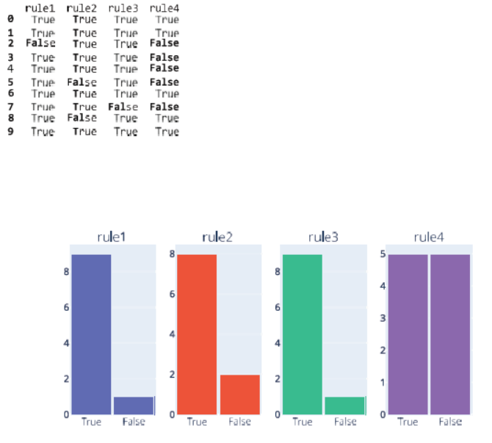

Ques2. Perform the following preprocessing tasks on the dirty_iris dataset.
i) Calculate the number and percentage of observations that are complete. • ii) Replace all the special values in data with NA. • iii) Define these rules in a separate text file and read them
Print the resulting constraint object. • Species should be one of the following values: setosa, versicolor or virginica. • All measured numerical properties of an iris should be positive. • The petal length of an iris is at least 2 times its petal width. • The sepal length of an iris cannot exceed 30 cm. • The sepals of an iris are longer than its petals. • iv) Determine how often each rule is broken (violatedEdits). Also summarize and plot theresult. • v) Find outliers in sepal length using boxplot and boxplot.stats
#importing necessary Libraries
import pandas as pd
import numpy as np
import matplotlib.pyplot as plt
import seaborn as sns
from plotly import graph_objs as go
from plotly.subplots import make_subplots
#importing the dataset
df = pd.read_csv('dirty_iris.txt')
df.head()
Sepal.Length Sepal.Width Petal.Length Petal.Width Species
0 6.4 3.2 4.5 1.5 versicolor
1 6.3 3.3 6.0 2.5 virginica
2 6.2 NaN 5.4 2.3 virginica
3 5.0 3.4 1.6 0.4 setosa
4 5.7 2.6 3.5 1.0 versicolor
df.shape
(150, 5)
df.info()
<class 'pandas.core.frame.DataFrame'>
RangeIndex: 150 entries, 0 to 149
Data columns (total 5 columns):
# Column Non-Null Count Dtype
--- ------ -------------- -----
0 Sepal.Length 140 non-null float64
1 Sepal.Width 133 non-null float64
2 Petal.Length 131 non-null float64
3 Petal.Width 138 non-null float64
4 Species 150 non-null object
dtypes: float64(4), object(1)
memory usage: 6.0+ KB
df.isna().sum()
Sepal.Length 10
Sepal.Width 17
Petal.Length 19
Petal.Width 12
Species 0
dtype: int64
#Number of complete obeservations(out of 150 total observations)
print(df.count(axis = 0))
new_n = df.dropna().shape[0]
print(new_n)
Sepal.Length 140
Sepal.Width 133
Petal.Length 131
Petal.Width 138
Species 150
dtype: int64
96
#Percentage of complete obeservations
missing = df.isnull().sum()
complete= 150 - missing
percent_complete = complete * 100 / len(df)
complete_value_df = pd.DataFrame({'column_name': df.columns,
'percent_complete': percent_complete})
print(complete_value_df)
n = df.shape[0]
percent=new_n * 100 / n
print(percent)
column_name percent_complete
Sepal.Length Sepal.Length 93.333333
Sepal.Width Sepal.Width 88.666667
Petal.Length Petal.Length 87.333333
Petal.Width Petal.Width 92.000000
Species Species 100.000000
64.0
#RepLace aLL the speciaL vaLues in data wit NA.
df.replace(to_replace ="@_!#$%^&*()<>?/\|}{-:", value = 'NA')
df.head()
Sepal.Length Sepal.Width Petal.Length Petal.Width Species
0 6.4 3.2 4.5 1.5 versicolor
1 6.3 3.3 6.0 2.5 virginica
2 6.2 NaN 5.4 2.3 virginica
3 5.0 3.4 1.6 0.4 setosa
4 5.7 2.6 3.5 1.0 versicolor
#Species shouLd be one of the foLLowing vaLues: setosa, versicoLor or virgin'
df['rule1']=df['Species'].isin(['setosa','versicolor', 'virginica'])
#ALL measured numericaL properties of an iris shouLd be positive.
rdf=df.drop(['Species', 'rule1'], axis=1)
df["rule2"]=(rdf < 0).any(axis=1)
#The petaL Length of an iris is at Least 2 times its petaL width.
df["rule3"]=(df['Petal.Length'] >= 2*df['Petal.Width'])
#The sepaL Length of an iris cannot exceed 30 cm.
df['rule4']=(df['Sepal.Length'] < 30)
#The sepals of an iris are Longer than its petals.
df['rule5']=(df['Sepal.Length'] > df['Petal.Length']) & (df['Sepal.Width'] > df['Petal.Width'])
df.head()
Sepal.Length Sepal.Width Petal.Length Petal.Width Species rule1 \
0 6.4 3.2 4.5 1.5 versicolor True
1 6.3 3.3 6.0 2.5 virginica True
2 6.2 NaN 5.4 2.3 virginica True
3 5.0 3.4 1.6 0.4 setosa True
4 5.7 2.6 3.5 1.0 versicolor True
rule2 rule3 rule4 rule5
0 False True True True
1 False True True True
2 False True True False
3 False True True True
4 False True True True
#Summarize the errors
print(df['rule1'].value_counts())
print(df['rule2'].value_counts())
print(df['rule3'].value_counts())
print(df['rule4'].value_counts())
print(df['rule5'].value_counts())
True 150
Name: rule1, dtype: int64
False 149
True 1
Name: rule2, dtype: int64
True 116
False 34
Name: rule3, dtype: int64
True 138
False 12
Name: rule4, dtype: int64
True 92
False 58
Name: rule5, dtype: int64
#VisuaLize the results obtained
newdf = df.filter(['rule1','rule2', 'rule3', 'rule4', 'rule5'], axis=1)
fig = make_subplots(rows=1, cols=5, subplot_titles=('rulel','rule2','rule3','rule4','rule5'))
L=(newdf)
cnames = list(newdf.columns)
for k, name in enumerate(cnames):
n_true = newdf[name].sum()
fig.add_trace(go.Bar(x=['True', 'False'], y=[n_true, L-n_true], name=name))
fig.update_layout(barmode='relative', bargap=0.05, width=700, height=400)
{"config":{"plotlyServerURL":"https://plot.ly"},"data":[{"name":"rule1","type":"bar","x":["True","False"],"y":[150,[[-149,-150,-149,-149,-149],[-149,-150,-149,-149,-149],[-149,-150,-149,-149,-150],[-149,-150,-149,-149,-149],[-149,-150,-149,-149,-149],[-149,-150,-150,-149,-150],[-149,-150,-150,-149,-150],[-149,-150,-149,-149,-149],[-149,-150,-149,-149,-149],[-149,-150,-149,-149,-149],[-149,-150,-149,-149,-149],[-149,-150,-149,-149,-149],[-149,-150,-150,-149,-150],[-149,-150,-149,-149,-149],[-149,-150,-149,-150,-150],[-149,-149,-149,-149,-150],[-149,-150,-149,-149,-150],[-149,-150,-149,-149,-149],[-149,-150,-150,-150,-150],[-149,-150,-149,-149,-150],[-149,-150,-150,-149,-150],[-149,-150,-149,-149,-150],[-149,-150,-150,-149,-150],[-149,-150,-149,-149,-149],[-149,-150,-149,-150,-150],[-149,-150,-149,-149,-149],[-149,-150,-149,-149,-149],[-149,-150,-150,-150,-150],[-149,-150,-149,-149,-149],[-149,-150,-150,-150,-150],[-149,-150,-150,-149,-150],[-149,-150,-150,-149,-150],[-149,-150,-149,-149,-149],[-149,-150,-150,-149,-150],[-149,-150,-149,-149,-150],[-149,-150,-149,-149,-149],[-149,-150,-149,-149,-149],[-149,-150,-149,-149,-149],[-149,-150,-149,-149,-149],…
fig = plt.figure(figsize=(10,7))
sns.boxplot(data = df['Sepal.Length'])

<Axes: >
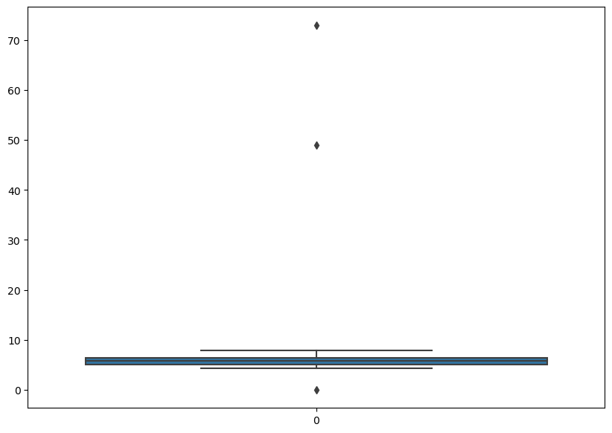
data = df['Sepal.Length']
pd.Series(data).describe()
max=data.max()
min=data.min()
iqr = (max - min)
upper = max + (iqr*1.5)
lower = min - (iqr*1.5)
iqr, upper, lower
(73.0, 182.5, -109.5)

Ques3. Load the data from wine dataset.
Check whether all attributes are standardized or not (mean is 0 and standard deviation is 1). If not, standardize the attributes. Do the same with Iris dataset.
import pandas as pd
import numpy as np
import matplotlib.pyplot as plt
dfwine = pd.read_csv('wine.csv')
dfwine.head()
Wine Alcohol Malic.acid Ash Acl Mg Phenols Flavanoids \
0 1 14.23 1.71 2.43 15.6 127 2.80 3.06
1 1 13.20 1.78 2.14 11.2 100 2.65 2.76
2 1 13.16 2.36 2.67 18.6 101 2.80 3.24
3 1 14.37 1.95 2.50 16.8 113 3.85 3.49
4 1 13.24 2.59 2.87 21.0 118 2.80 2.69
Nonflavanoid.phenols Proanth Color.int Hue OD Proline
0 0.28 2.29 5.64 1.04 3.92 1065
1 0.26 1.28 4.38 1.05 3.40 1050
2 0.30 2.81 5.68 1.03 3.17 1185
3 0.24 2.18 7.80 0.86 3.45 1480
4 0.39 1.82 4.32 1.04 2.93 735
dfwine.describe()
Wine Alcohol Malic.acid Ash Acl Mg \
count 178.000000 178.000000 178.000000 178.000000 178.000000 178.000000
mean 1.938202 13.000618 2.336348 2.366517 19.494944 99.741573
std 0.775035 0.811827 1.117146 0.274344 3.339564 14.282484
min 1.000000 11.030000 0.740000 1.360000 10.600000 70.000000
25% 1.000000 12.362500 1.602500 2.210000 17.200000 88.000000
50% 2.000000 13.050000 1.865000 2.360000 19.500000 98.000000
75% 3.000000 13.677500 3.082500 2.557500 21.500000 107.000000
max 3.000000 14.830000 5.800000 3.230000 30.000000 162.000000
Phenols Flavanoids Nonflavanoid.phenols Proanth Color.int \
count 178.000000 178.000000 178.000000 178.000000 178.000000
mean 2.295112 2.029270 0.361854 1.590899 5.058090
std 0.625851 0.998859 0.124453 0.572359 2.318286
min 0.980000 0.340000 0.130000 0.410000 1.280000
25% 1.742500 1.205000 0.270000 1.250000 3.220000
50% 2.355000 2.135000 0.340000 1.555000 4.690000
75% 2.800000 2.875000 0.437500 1.950000 6.200000
max 3.880000 5.080000 0.660000 3.580000 13.000000
Hue OD Proline
count 178.000000 178.000000 178.000000
mean 0.957449 2.611685 746.893258
std 0.228572 0.709990 314.907474
min 0.480000 1.270000 278.000000
25% 0.782500 1.937500 500.500000
50% 0.965000 2.780000 673.500000
75% 1.120000 3.170000 985.000000
max 1.710000 4.000000 1680.000000
dfiris = pd.read_csv('iris.csv')
dfiris.head(5)
5.1 3.5 1.4 0.2 Iris-setosa
0 4.9 3.0 1.4 0.2 Iris-setosa
1 4.7 3.2 1.3 0.2 Iris-setosa
2 4.6 3.1 1.5 0.2 Iris-setosa
3 5.0 3.6 1.4 0.2 Iris-setosa
4 5.4 3.9 1.7 0.4 Iris-setosa
dfiris.describe()
5.1 3.5 1.4 0.2
count 149.000000 149.000000 149.000000 149.000000
mean 5.848322 3.051007 3.774497 1.205369
std 0.828594 0.433499 1.759651 0.761292
min 4.300000 2.000000 1.000000 0.100000
25% 5.100000 2.800000 1.600000 0.300000
50% 5.800000 3.000000 4.400000 1.300000
75% 6.400000 3.300000 5.100000 1.800000
max 7.900000 4.400000 6.900000 2.500000
x = dfiris.iloc[:,:-1]
y = dfiris.iloc[:,-1]
from sklearn.model_selection import train_test_split
from sklearn.preprocessing import StandardScaler
x_train,x_test, y_train, y_test = train_test_split(x,y,test_size=0.2)
#Standardizing Iris dataframe
std_s = StandardScaler() #making object of standard scaler
std_s.fit(x_train)
x_train_std = std_s.transform(x_train)
x_test_std = std_s.transform(x_test)
print(x_train[0:5])
print(x_train_std[0:5])
print(x_test[0:5])
print(x_test_std[0:5])
5.1 3.5 1.4 0.2
99 6.3 3.3 6.0 2.5
143 6.7 3.3 5.7 2.5
119 6.9 3.2 5.7 2.3
61 6.0 2.2 4.0 1.0
76 6.7 3.0 5.0 1.7
[[ 0.55939671 0.56863198 1.3081895 1.75726247]
[ 1.04886883 0.56863198 1.13418665 1.75726247]
[ 1.2936049 0.33925162 1.13418665 1.48865074]
[ 0.19229262 -1.95455195 0.14817049 -0.25732553]
[ 1.04886883 -0.11950909 0.72818 0.68281554]]
5.1 3.5 1.4 0.2
9 5.4 3.7 1.5 0.2
16 5.1 3.5 1.4 0.3
116 7.7 3.8 6.7 2.2
139 6.7 3.1 5.6 2.4
141 5.8 2.7 5.1 1.9
[[-0.54191556 1.4861534 -1.30185326 -1.33177246]
[-0.90901966 1.02739269 -1.35985421 -1.19746659]
[ 2.27254914 1.71553376 1.71419615 1.35434487]
[ 1.04886883 0.10987126 1.0761857 1.62295661]
[-0.05244344 -0.80765016 0.78618095 0.95142727]]
#Standardising all records of independent variable simultaneously
scaled_dfiris=std_s.fit_transform(x)
scaled_dfiris
array([[-1.1483555 , -0.11805969, -1.35396443, -1.32506301],
[-1.3905423 , 0.34485856, -1.41098555, -1.32506301],
[-1.51163569, 0.11339944, -1.29694332, -1.32506301],
[-1.02726211, 1.27069504, -1.35396443, -1.32506301],
[-0.54288852, 1.9650724 , -1.18290109, -1.0614657 ],
[-1.51163569, 0.8077768 , -1.35396443, -1.19326436],
[-1.02726211, 0.8077768 , -1.29694332, -1.32506301],
[-1.75382249, -0.34951881, -1.35396443, -1.32506301],
[-1.1483555 , 0.11339944, -1.29694332, -1.45686167],
[-0.54288852, 1.50215416, -1.29694332, -1.32506301],
[-1.2694489 , 0.8077768 , -1.23992221, -1.32506301],
[-1.2694489 , -0.11805969, -1.35396443, -1.45686167],
[-1.87491588, -0.11805969, -1.52502777, -1.45686167],
[-0.05851493, 2.19653152, -1.46800666, -1.32506301],
[-0.17960833, 3.122368 , -1.29694332, -1.0614657 ],
[-0.54288852, 1.9650724 , -1.41098555, -1.0614657 ],
[-0.90616871, 1.03923592, -1.35396443, -1.19326436],
[-0.17960833, 1.73361328, -1.18290109, -1.19326436],
[-0.90616871, 1.73361328, -1.29694332, -1.19326436],
[-0.54288852, 0.8077768 , -1.18290109, -1.32506301],
[-0.90616871, 1.50215416, -1.29694332, -1.0614657 ],
[-1.51163569, 1.27069504, -1.58204889, -1.32506301],
#Doing for wine DataFrame
xwine= dfwine.iloc[:,:-1]
ywine= dfwine.iloc[:,-1]
xwine.values
array([[ 1. , 14.23, 1.71, ..., 5.64, 1.04, 3.92],
[ 1. , 13.2 , 1.78, ..., 4.38, 1.05, 3.4 ],
[ 1. , 13.16, 2.36, ..., 5.68, 1.03, 3.17],
...,
[ 3. , 13.27, 4.28, ..., 10.2 , 0.59, 1.56],
[ 3. , 13.17, 2.59, ..., 9.3 , 0.6 , 1.62],
[ 3. , 14.13, 4.1 , ..., 9.2 , 0.61, 1.6 ]])
ywine.values
array([1065, 1050, 1185, 1480, 735, 1450, 1290, 1295, 1045, 1045, 1510,
1280, 1320, 1150, 1547, 1310, 1280, 1130, 1680, 845, 780, 770,
1035, 1015, 845, 830, 1195, 1285, 915, 1035, 1285, 1515, 990,
1235, 1095, 920, 880, 1105, 1020, 760, 795, 1035, 1095, 680,
885, 1080, 1065, 985, 1060, 1260, 1150, 1265, 1190, 1375, 1060,
1120, 970, 1270, 1285, 520, 680, 450, 630, 420, 355, 678,
502, 510, 750, 718, 870, 410, 472, 985, 886, 428, 392,
500, 750, 463, 278, 714, 630, 515, 520, 450, 495, 562,
680, 625, 480, 450, 495, 290, 345, 937, 625, 428, 660,
406, 710, 562, 438, 415, 672, 315, 510, 488, 312, 680,
562, 325, 607, 434, 385, 407, 495, 345, 372, 564, 625,
465, 365, 380, 380, 378, 352, 466, 342, 580, 630, 530,
560, 600, 650, 695, 720, 515, 580, 590, 600, 780, 520,
550, 855, 830, 415, 625, 650, 550, 500, 480, 425, 675,
640, 725, 480, 880, 660, 620, 520, 680, 570, 675, 615,
520, 695, 685, 750, 630, 510, 470, 660, 740, 750, 835,
840, 560], dtype=int64)
xwine_train,xwine_test, ywine_train, ywine_test = train_test_split(x,y,test_size=0.2)
# Standardising wine dataset
obj2 = StandardScaler() #making object
obj2.fit(xwine_train)
xwine_train_std = obj2.transform(xwine_train)
xwine_test_std = obj2.transform(xwine_test)
print(xwine_train[0:6])
print(xwine_train_std[0:6])
print(xwine_test[0:6])
print(xwine_test_std[0:6])
5.1 3.5 1.4 0.2
43 5.1 3.8 1.9 0.4
56 4.9 2.4 3.3 1.0
53 6.5 2.8 4.6 1.5
138 6.9 3.1 5.4 2.1
26 5.2 3.5 1.5 0.2
5 4.6 3.4 1.4 0.3
[[-0.91568689 1.90970508 -1.15182667 -1.14861124]
[-1.15360553 -1.59422516 -0.34351023 -0.35316175]
[ 0.74974363 -0.59310224 0.40706933 0.30971283]
[ 1.22558092 0.15773996 0.86896444 1.10516232]
[-0.79672757 1.15886288 -1.38277423 -1.41376107]
[-1.5104835 0.90858215 -1.44051112 -1.28118615]]
5.1 3.5 1.4 0.2
129 7.4 2.8 6.1 1.9
122 6.3 2.7 4.9 1.8
13 5.8 4.0 1.2 0.2
27 5.2 3.4 1.4 0.2
4 5.4 3.9 1.7 0.4
116 7.7 3.8 6.7 2.2
[[ 1.82037754 -0.59310224 1.27312266 0.84001249]
[ 0.51182499 -0.84338297 0.58027999 0.70743757]
[-0.08297163 2.41026654 -1.5559849 -1.41376107]
[-0.79672757 0.90858215 -1.44051112 -1.41376107]
[-0.55880892 2.15998581 -1.26730045 -1.14861124]
[ 2.17725551 1.90970508 1.61954399 1.23773723]]
#Standardising all records of independent variable simultaneously
scaled_dfwine= obj2.fit_transform(xwine)
scaled_dfwine
array([[-1.21394365, 1.51861254, -0.5622498 , ..., 0.25171685,
0.36217728, 1.84791957],
[-1.21394365, 0.24628963, -0.49941338, ..., -0.29332133,
0.40605066, 1.1134493 ],
[-1.21394365, 0.19687903, 0.02123125, ..., 0.26901965,
0.31830389, 0.78858745],
...,
[ 1.37386437, 0.33275817, 1.74474449, ..., 2.22423597,
-1.61212515, -1.48544548],
[ 1.37386437, 0.20923168, 0.22769377, ..., 1.83492299,
-1.56825176, -1.40069891],
[ 1.37386437, 1.39508604, 1.58316512, ..., 1.79166599,
-1.52437837, -1.42894777]])

Ques4.Run Apriori algorithm to find frequent itemsets and association rules
4.1 Use minimum support as 50% and minimum confidence as 75% 4.2 Use minimum support as 60% and minimum confidence as 60 %
import pandas as pd
from mlxtend.preprocessing import TransactionEncoder
from mlxtend.frequent_patterns import apriori
from mlxtend.frequent_patterns import association_rules
dataset=[['Milk', 'Onion', 'Nutmeg', 'Kidney Beans', 'Eggs', 'Yogurt'],
['Dill', 'Onion', 'Nutmeg', 'Kidney Beans', 'Eggs', 'Yogurt'],
['Milk', 'Apple', 'Kidney Beans', 'Eggs'],
['Milk', 'Unicorn', 'Corn', 'Kidney Beans', 'Yogurt'],
['Corn', 'Onion', 'Onion', 'Kidney Beans', 'Ice cream' , 'Eggs']]
te=TransactionEncoder()
te_ary=te.fit(dataset).transform(dataset)
df=pd.DataFrame(te_ary, columns=te.columns_)
df.head()
Apple Corn Dill Eggs Ice cream Kidney Beans Milk Nutmeg Onion \
0 False False False True False True True True True
1 False False True True False True False True True
2 True False False True False True True False False
3 False True False False False True True False False
4 False True False True True True False False True
Unicorn Yogurt
0 False True
1 False True
2 False False
3 True True
4 False False
frequent_itemsets=apriori(df, min_support=0.5, use_colnames=True)
frequent_itemsets
support itemsets
0 0.8 (Eggs)
1 1.0 (Kidney Beans)
2 0.6 (Milk)
3 0.6 (Onion)
4 0.6 (Yogurt)
5 0.8 (Kidney Beans, Eggs)
6 0.6 (Onion, Eggs)
7 0.6 (Milk, Kidney Beans)
8 0.6 (Kidney Beans, Onion)
9 0.6 (Yogurt, Kidney Beans)
10 0.6 (Kidney Beans, Onion, Eggs)
res= association_rules(frequent_itemsets, metric="confidence", min_threshold=0.75)
print(res)
antecedents consequents antecedent support \
0 (Kidney Beans) (Eggs) 1.0
1 (Eggs) (Kidney Beans) 0.8
2 (Onion) (Eggs) 0.6
3 (Milk) (Kidney Beans) 0.6
4 (Onion) (Kidney Beans) 0.6
5 (Yogurt) (Kidney Beans) 0.6
6 (Kidney Beans, Onion) (Eggs) 0.6
7 (Onion, Eggs) (Kidney Beans) 0.6
8 (Onion) (Kidney Beans, Eggs) 0.6
consequent support support confidence lift leverage conviction \
0 0.8 0.8 0.8 1.00 0.00 1.0
1 1.0 0.8 1.0 1.00 0.00 inf
2 0.8 0.6 1.0 1.25 0.12 inf
3 1.0 0.6 1.0 1.00 0.00 inf
4 1.0 0.6 1.0 1.00 0.00 inf
5 1.0 0.6 1.0 1.00 0.00 inf
6 0.8 0.6 1.0 1.25 0.12 inf
7 1.0 0.6 1.0 1.00 0.00 inf
8 0.8 0.6 1.0 1.25 0.12 inf
zhangs_metric
0 0.0
1 0.0
2 0.5
3 0.0
4 0.0
5 0.0
6 0.5
7 0.0
8 0.5

Ques5. Use Naive bayes, K-nearest, and Decision tree classification algorithms and buildclassifiers. Divide the data set in to training and test set.
Compare the accuracy of thedifferent classifiers under the following situations:
5.1 a) Training set = 75% Test set = 25% 5.1 b) Training set = 66.6% (2/3rd of total), Test set = 33.3% 5.2 Training set is chosen by
i) hold out method
ii) Random subsampling
iii) Cross-Validation. Compare the accuracy of the classifiers obtained. 5.3 Data is scaled to standard format.

#importing necessary Libraries
import pandas as pd
import numpy as np
import matplotlib.pyplot as plt
import seaborn as sns
%matplotlib inline
import warnings
warnings.filterwarnings('ignore')
#importing libraries for machine learning
from sklearn.model_selection import train_test_split
from sklearn.preprocessing import StandardScaler
from sklearn.naive_bayes import GaussianNB
from sklearn.neighbors import KNeighborsClassifier
from sklearn.tree import DecisionTreeClassifier
from sklearn.metrics import confusion_matrix, accuracy_score
from sklearn.metrics import classification_report
from sklearn import metrics
from sklearn import model_selection
#importing the dataset
df = pd.read_csv('diabetes.csv')
df.head()
Pregnancies Glucose BloodPressure SkinThickness Insulin BMI \
0 6 148 72 35 0 33.6
1 1 85 66 29 0 26.6
2 8 183 64 0 0 23.3
3 1 89 66 23 94 28.1
4 0 137 40 35 168 43.1
DiabetesPedigreeFunction Age Outcome
0 0.627 50 1
1 0.351 31 0
2 0.672 32 1
3 0.167 21 0
4 2.288 33 1
df.info()
<class 'pandas.core.frame.DataFrame'>
RangeIndex: 768 entries, 0 to 767
Data columns (total 9 columns):
# Column Non-Null Count Dtype
--- ------ -------------- -----
0 Pregnancies 768 non-null int64
1 Glucose 768 non-null int64
2 BloodPressure 768 non-null int64
3 SkinThickness 768 non-null int64
4 Insulin 768 non-null int64
5 BMI 768 non-null float64
6 DiabetesPedigreeFunction 768 non-null float64
7 Age 768 non-null int64
8 Outcome 768 non-null int64
dtypes: float64(2), int64(7)
memory usage: 54.1 KB
df.isna().sum()
Pregnancies 0
Glucose 0
BloodPressure 0
SkinThickness 0
Insulin 0
BMI 0
DiabetesPedigreeFunction 0
Age 0
Outcome 0
dtype: int64
fig = plt.figure(figsize=(10,5))
#1
plt.subplot(1,2,1)
sns.countplot(x = 'Outcome', data = df)
#2
plt.subplot(1,2,2)
df['Outcome'].value_counts().plot.pie(startangle = 90,autopct = '%1.1f%%')
plt.show()
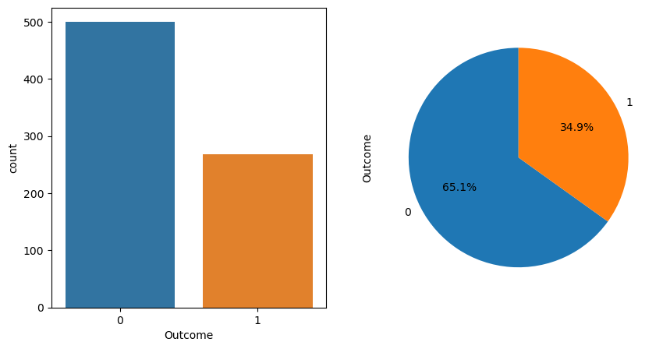
#assigning independent variables to x and dependent variable or response var
x = df.drop('Outcome',axis = 1)
y = df['Outcome']

1.Naive Bayers

5.1a) Splitting the dataframe into training and testing data in 75:25 ratio
x_train, x_test, y_train, y_test = train_test_split(x,y,test_size = 0.25, random_state=25)
gbl = GaussianNB()
gbl.fit(x_train, y_train)
y_pred = gbl.predict(x_test)
y_pred
print(confusion_matrix(y_test,y_pred))
print("Classification report : \n", classification_report(y_test,y_pred))
acl = accuracy_score(y_test,y_pred)
print("Accuracy Score:",acl)
[[107 23]
[ 23 39]]
Classification report :
precision recall f1-score support
0 0.82 0.82 0.82 130
1 0.63 0.63 0.63 62
accuracy 0.76 192
macro avg 0.73 0.73 0.73 192
weighted avg 0.76 0.76 0.76 192
Accuracy Score: 0.7604166666666666

5.1b) Splitting the dataframe into training and testing data in 66.6:33.3 ratio
x_train, x_test, y_train, y_test = train_test_split(x,y,test_size = 0.333, random_state=25)
gb2 = GaussianNB()
gb2.fit(x_train, y_train)
y_pred = gb2.predict(x_test)
y_pred
print(confusion_matrix(y_test,y_pred))
print("Classification report : \n", classification_report(y_test,y_pred))
ac2 = accuracy_score(y_test,y_pred)
print("Accuracy Score:",ac2)
[[145 26]
[ 26 59]]
Classification report :
precision recall f1-score support
0 0.85 0.85 0.85 171
1 0.69 0.69 0.69 85
accuracy 0.80 256
macro avg 0.77 0.77 0.77 256
weighted avg 0.80 0.80 0.80 256
Accuracy Score: 0.796875

Comparing accuracy score of 25% and 33.3% split
if acl > ac2:
print("Test data of 25% data is better")
else:
print("Test data of 33.3% data is better")
Test data of 33.3% data is better

5.2(i) Holdout Method
x_train, x_test, y_train, y_test = train_test_split(x,y,test_size = 0.25, random_state=25)
gb3 = GaussianNB()
gb3.fit(x_train, y_train)
y_pred = gb3.predict(x_test)
y_pred
print(confusion_matrix(y_test,y_pred))
print("Classification report : \n", classification_report(y_test,y_pred))
ac3 = accuracy_score(y_test,y_pred)
print("Accuracy Score:",ac3)
[[107 23]
[ 23 39]]
Classification report :
precision recall f1-score support
0 0.82 0.82 0.82 130
1 0.63 0.63 0.63 62
accuracy 0.76 192
macro avg 0.73 0.73 0.73 192
weighted avg 0.76 0.76 0.76 192
Accuracy Score: 0.7604166666666666

5.2(iii) K Fold Cross Validation
kfold = model_selection.KFold(n_splits =5,random_state=10,shuffle = True)
result = model_selection.cross_val_score(gbl,x_train,y_train,cv = kfold)
print(result)
print("Avg accuracy: {}".format(result.mean()))
[0.70689655 0.80869565 0.74782609 0.7826087 0.76521739]
Avg accuracy: 0.7622488755622189

Comparing Hold Method and Cross Validation
print("K Fold performs better than cross validation")
K Fold performs better than cross validation

5.3 Standard Scaler
x_train, x_test, y_train, y_test = train_test_split(x,y,test_size = 0.20, random_state=25)
sc = StandardScaler()
x_train = sc.fit_transform(x_train)
x_test = sc.transform(x_test)
gb5 = GaussianNB()
gb5.fit(x_train, y_train)
y_pred = gb5.predict(x_test)
y_pred
print(confusion_matrix(y_test,y_pred))
print("Classification report : \n", classification_report(y_test,y_pred))
ac5 = accuracy_score(y_test,y_pred)
print("Accuracy Score:",ac5)
[[87 16]
[20 31]]
Classification report :
precision recall f1-score support
0 0.81 0.84 0.83 103
1 0.66 0.61 0.63 51
accuracy 0.77 154
macro avg 0.74 0.73 0.73 154
weighted avg 0.76 0.77 0.76 154
Accuracy Score: 0.7662337662337663

Comparing Standard Scaler with default parameters
print("Standard Scaler performs better")
Standard Scaler performs better

KNN Model

5.1a) Splitting the dataframe into training and testing data in 75:25 ratio
x_train, x_test, y_train, y_test = train_test_split(x,y,test_size = 0.25, random_state=25)
test_scores = []
train_scores = []
for i in range(1,15):
knn = KNeighborsClassifier(i)
knn.fit(x_train,y_train)
train_scores.append(knn.score(x_train,y_train))
test_scores.append(knn.score(x_test,y_test))
plt.figure(figsize = (10,5))
p = sns.lineplot(range(1,15),train_scores,marker='*',label='Train Score')
p = sns.lineplot(range(1,15),test_scores,marker='o',label='Test Score')
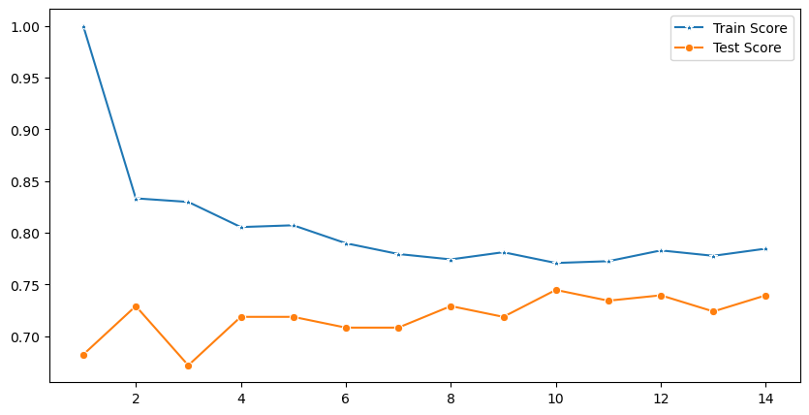
k1 = KNeighborsClassifier(n_neighbors = 11)
k1.fit(x_train,y_train)
y_pred = k1.predict(x_test)
print(confusion_matrix(y_test,y_pred))
print("Classification report : \n", classification_report(y_test,y_pred))
acl = accuracy_score(y_test,y_pred)
print("Accuracy Score:",acl)
[[110 20]
[ 31 31]]
Classification report :
precision recall f1-score support
0 0.78 0.85 0.81 130
1 0.61 0.50 0.55 62
accuracy 0.73 192
macro avg 0.69 0.67 0.68 192
weighted avg 0.72 0.73 0.73 192
Accuracy Score: 0.734375

5.1b) Splitting the dataframe into training and testing data in 66.6:33.3ratio
x_train, x_test, y_train, y_test = train_test_split(x,y,test_size = 0.333, random_state=25)
test_scores = []
train_scores = []
for i in range(1,15):
knn = KNeighborsClassifier(i)
knn.fit(x_train,y_train)
train_scores.append(knn.score(x_train,y_train))
test_scores.append(knn.score(x_test,y_test))
plt.figure(figsize = (10,5))
p = sns.lineplot(range(1,15),train_scores,marker='*',label='Train Score')
p = sns.lineplot(range(1,15),test_scores,marker='o',label='Test Score')
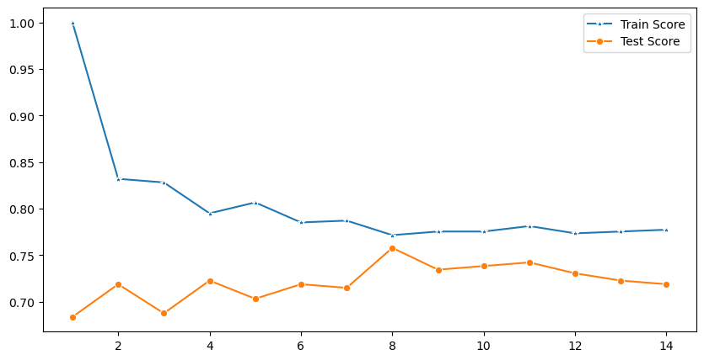
k2 = KNeighborsClassifier(n_neighbors = 9)
k2.fit(x_train,y_train)
y_pred = k2.predict(x_test)
print(confusion_matrix(y_test,y_pred))
print("Classification report : \n", classification_report(y_test,y_pred))
ac2 = accuracy_score(y_test,y_pred)
print("Accuracy Score:",ac2)
[[144 27]
[ 41 44]]
Classification report :
precision recall f1-score support
0 0.78 0.84 0.81 171
1 0.62 0.52 0.56 85
accuracy 0.73 256
macro avg 0.70 0.68 0.69 256
weighted avg 0.73 0.73 0.73 256
Accuracy Score: 0.734375

Comparing accuracy score of 25% and 33.3% split
if acl > ac2:
print("Test data of 25% data is better")
else:
print("Test data of 33.3% data is better")
Test data of 33.3% data is better

5.2(i) Holdout Method
x_train, x_test, y_train, y_test = train_test_split(x,y,test_size = 0.25, random_state=10)
test_scores = []
train_scores = []
for i in range(1,15):
knn = KNeighborsClassifier(i)
knn.fit(x_train,y_train)
train_scores.append(knn.score(x_train,y_train))
test_scores.append(knn.score(x_test,y_test))
plt.figure(figsize = (10,5))
p = sns.lineplot(range(1,15),train_scores,marker='*',label='Train Score')
p = sns.lineplot(range(1,15),test_scores,marker='o',label='Test Score')
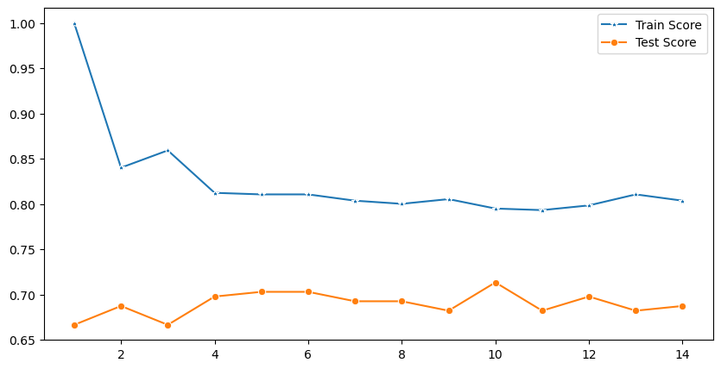
k3 = KNeighborsClassifier(n_neighbors = 9)
k3.fit(x_train,y_train)
y_pred = k3.predict(x_test)
print(confusion_matrix(y_test,y_pred))
print("Classification report : \n", classification_report(y_test,y_pred))
ac3 = accuracy_score(y_test,y_pred)
print("Accuracy Score:",ac3)
[[100 21]
[ 40 31]]
Classification report :
precision recall f1-score support
0 0.71 0.83 0.77 121
1 0.60 0.44 0.50 71
accuracy 0.68 192
macro avg 0.66 0.63 0.64 192
weighted avg 0.67 0.68 0.67 192
Accuracy Score: 0.6822916666666666

5.2(iii) K Fold Cross Validation
print("K Fold performs better than cross validation")
K Fold performs better than cross validation

5.3 Standard Scaler
x_train, x_test, y_train, y_test = train_test_split(x,y,test_size = 0.20, random_state=10)
test_scores = []
train_scores = []
for i in range(1,15):
knn = KNeighborsClassifier(i)
knn.fit(x_train,y_train)
train_scores.append(knn.score(x_train,y_train))
test_scores.append(knn.score(x_test,y_test))
plt.figure(figsize = (10,5))
p = sns.lineplot(range(1,15),train_scores,marker='*',label='Train Score')
p = sns.lineplot(range(1,15),test_scores,marker='o',label='Test Score')
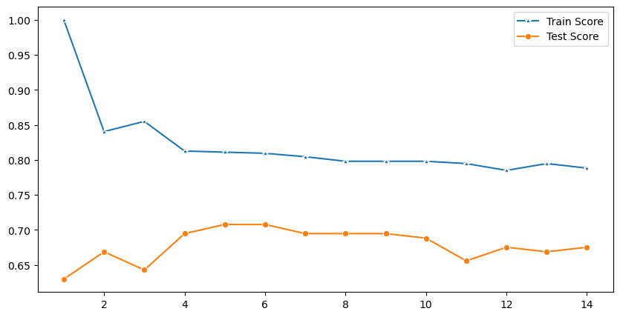
k5 = KNeighborsClassifier(n_neighbors = 9)
k5.fit(x_train,y_train)
y_pred = k5.predict(x_test)
print(confusion_matrix(y_test,y_pred))
print("Classification report : \n", classification_report(y_test,y_pred))
ac5 = accuracy_score(y_test,y_pred)
print("Accuracy Score:",ac5)
[[78 17]
[30 29]]
Classification report :
precision recall f1-score support
0 0.72 0.82 0.77 95
1 0.63 0.49 0.55 59
accuracy 0.69 154
macro avg 0.68 0.66 0.66 154
weighted avg 0.69 0.69 0.69 154
Accuracy Score: 0.6948051948051948

Comparing Standard Scaler with default parameters
print("Standard Scaler performs better")
Standard Scaler performs better

2.Decision Tree

5.1a) Splitting the dataframe into training and testing data in 75:25 ratio
x_train, x_test, y_train, y_test = train_test_split(x,y,test_size = 0.25, random_state=25)
dt1 = DecisionTreeClassifier()
dt1.fit(x_train, y_train)
y_pred = dt1.predict(x_test)
y_pred
print(confusion_matrix(y_test,y_pred))
print("Classification report : \n", classification_report(y_test,y_pred))
ac1 = accuracy_score(y_test,y_pred)
print("Accuracy Score:",ac1)
[[100 30]
[ 30 32]]
Classification report :
precision recall f1-score support
0 0.77 0.77 0.77 130
1 0.52 0.52 0.52 62
accuracy 0.69 192
macro avg 0.64 0.64 0.64 192
weighted avg 0.69 0.69 0.69 192
Accuracy Score: 0.6875

5.1(b) Splitting the dataframe into training and testing data in 66.6:33.3 ratio
x_train, x_test, y_train, y_test = train_test_split(x,y,test_size = 0.333, random_state=25)
dt2 = DecisionTreeClassifier()
dt2.fit(x_train, y_train)
y_pred = dt2.predict(x_test)
y_pred
print(confusion_matrix(y_test,y_pred))
print("Classification report : \n", classification_report(y_test,y_pred))
ac2 = accuracy_score(y_test,y_pred)
print("Accuracy Score:",ac2)
[[129 42]
[ 33 52]]
Classification report :
precision recall f1-score support
0 0.80 0.75 0.77 171
1 0.55 0.61 0.58 85
accuracy 0.71 256
macro avg 0.67 0.68 0.68 256
weighted avg 0.72 0.71 0.71 256
Accuracy Score: 0.70703125

Comparing accuracy score of 25% and 33.3% split
if acl > ac2:
print("Test data of 25% data is better")
else:
print("Test data of 33.3% data is better")
Test data of 25% data is better

5.2(i) Holdout Method
x_train, x_test, y_train, y_test = train_test_split(x,y,test_size = 0.25, random_state=25)
dt3 = DecisionTreeClassifier()
dt3.fit(x_train, y_train)
y_pred = dt3.predict(x_test)
y_pred
print(confusion_matrix(y_test,y_pred))
print("Classification report : \n", classification_report(y_test,y_pred))
ac3 = accuracy_score(y_test,y_pred)
print("Accuracy Score:",ac3)
[[105 25]
[ 30 32]]
Classification report :
precision recall f1-score support
0 0.78 0.81 0.79 130
1 0.56 0.52 0.54 62
accuracy 0.71 192
macro avg 0.67 0.66 0.67 192
weighted avg 0.71 0.71 0.71 192
Accuracy Score: 0.7135416666666666

5.2(iii) K Fold Cross Validation
kfold = model_selection.KFold(n_splits = 5,random_state = 10,shuffle = True)
result = model_selection.cross_val_score(gbl,x_train,y_train,cv = kfold)
print(result)
print("Avg accuracy: {}".format(result.mean()))
[0.70689655 0.80869565 0.74782609 0.7826087 0.76521739]
Avg accuracy: 0.7622488755622189

Comparing Hold Method and Cross Validation
print("K Fold performs better than cross validation")
K Fold performs better than cross validation

5.3 Standard Scaler
x_train, x_test, y_train, y_test = train_test_split(x,y,test_size = 0.20, random_state=25)
dt5 = DecisionTreeClassifier()
dt5.fit(x_train, y_train)
y_pred = dt5.predict(x_test)
y_pred
print(confusion_matrix(y_test,y_pred))
print("Classification report : \n", classification_report(y_test,y_pred))
ac5 = accuracy_score(y_test,y_pred)
print("Accuracy Score:",ac5)
[[84 19]
[26 25]]
Classification report :
precision recall f1-score support
0 0.76 0.82 0.79 103
1 0.57 0.49 0.53 51
accuracy 0.71 154
macro avg 0.67 0.65 0.66 154
weighted avg 0.70 0.71 0.70 154
Accuracy Score: 0.7077922077922078

Comparing Standard Scaler with default parameters
print("Standard Scaler performs better ")
Standard Scaler performs better

Ques6. Use Simple Kmeans, DBScan, Hierachical clustering algorithms for clustering.
Compare the performance of clustersby changing the parameters involved in thealgorithms
#importing necessary Libraries
import pandas as pd
import numpy as np
import seaborn as sns
import matplotlib.pyplot as plt
import warnings
warnings.filterwarnings ('ignore')
#importing libraries for machine learning
from sklearn.preprocessing import MinMaxScaler
from sklearn.preprocessing import StandardScaler
from sklearn.preprocessing import normalize
from sklearn.cluster import KMeans
import scipy.cluster.hierarchy as shc
from sklearn.cluster import AgglomerativeClustering
from sklearn.metrics import silhouette_score
from sklearn.neighbors import NearestNeighbors
from sklearn.cluster import DBSCAN
#importing the dataset
df = pd.read_csv('wine.csv')
df.head(5)
Wine Alcohol Malic.acid Ash Acl Mg Phenols Flavanoids \
0 1 14.23 1.71 2.43 15.6 127 2.80 3.06
1 1 13.20 1.78 2.14 11.2 100 2.65 2.76
2 1 13.16 2.36 2.67 18.6 101 2.80 3.24
3 1 14.37 1.95 2.50 16.8 113 3.85 3.49
4 1 13.24 2.59 2.87 21.0 118 2.80 2.69
Nonflavanoid.phenols Proanth Color.int Hue OD Proline
0 0.28 2.29 5.64 1.04 3.92 1065
1 0.26 1.28 4.38 1.05 3.40 1050
2 0.30 2.81 5.68 1.03 3.17 1185
3 0.24 2.18 7.80 0.86 3.45 1480
4 0.39 1.82 4.32 1.04 2.93 735
df.info()
<class 'pandas.core.frame.DataFrame'>
RangeIndex: 178 entries, 0 to 177
Data columns (total 14 columns):
# Column Non-Null Count Dtype
--- ------ -------------- -----
0 Wine 178 non-null int64
1 Alcohol 178 non-null float64
2 Malic.acid 178 non-null float64
3 Ash 178 non-null float64
4 Acl 178 non-null float64
5 Mg 178 non-null int64
6 Phenols 178 non-null float64
7 Flavanoids 178 non-null float64
8 Nonflavanoid.phenols 178 non-null float64
9 Proanth 178 non-null float64
10 Color.int 178 non-null float64
11 Hue 178 non-null float64
12 OD 178 non-null float64
13 Proline 178 non-null int64
dtypes: float64(11), int64(3)
memory usage: 19.6 KB

K-Means Model
x = df.iloc[:,:].values
mms = MinMaxScaler()
x = mms.fit_transform(x)

Elbow Method
#To identify the exact no of clusters we will use elbow method
dist =[]
for i in range(1,20):
kmodel = KMeans(
n_clusters = i, init = 'random',
n_init = 10, max_iter = 300,
tol = 1e-04, random_state = 65
)
kmodel.fit(x)
dist.append(kmodel.inertia_)
fig = plt.figure(figsize=(10,7))
plt.plot(range(1,20),dist,
marker="o")
plt.xlabel('No. of Clusters "k" ')
plt.ylabel('Sum of squared distance')
plt.title('Elbow Method for Optimal k')
plt.show()
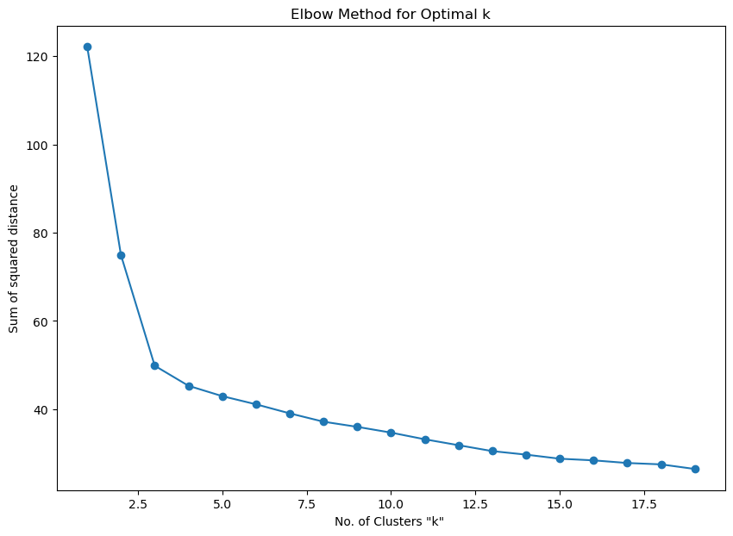
dist =[]
for i in range(1,20):
kmodel = KMeans(
n_clusters = i, init = 'random',
n_init = 10, max_iter = 300,
tol = 1e-04, random_state = 65
)
kmodel.fit(x)
dist.append(kmodel.inertia_)
fig = plt.figure(figsize=(10,7))
plt.plot(range(1,20),dist,
marker="o")
plt.xlabel('No. of Clusters "k" ')
plt.ylabel('Sum of squared distance')
plt.title('Elbow Method for Optimal k')
plt.axvline(3, ls="--"
, c="red")
plt.show()
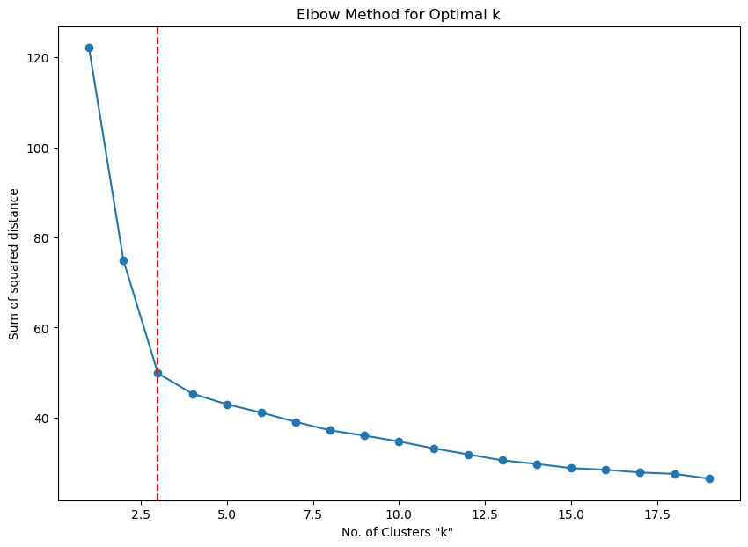

From the above Elbow graph it can be inferred that 3 clusters can be chosen for segmentation
#K - Means model with 3 clusters
kmodel = KMeans(
n_clusters = 3, init = 'random',
n_init = 10, max_iter = 300,
tol = 1e-04, random_state = 65
)
pred = kmodel.fit_predict(x)
plt.figure(figsize = (12,10))
plt.scatter(
x[pred == 0, 2], x[pred == 0, 6],
s = 50, c = 'lightgreen',
marker = 's', edgecolor = 'black',
label = 'cluster 1'
)
plt.scatter(
x[pred == 1, 2], x[pred == 1, 6],
s = 50, c = 'orange',
marker = 'o', edgecolor = 'black',
label = 'cluster 2'
)
plt.scatter(
x[pred == 2, 2], x[pred == 2, 6],
s = 50, c = 'lightblue',
marker = 'v', edgecolor = 'black',
label ='cluster 3'
)
plt.legend()
<matplotlib.legend.Legend at 0x281a655af20>
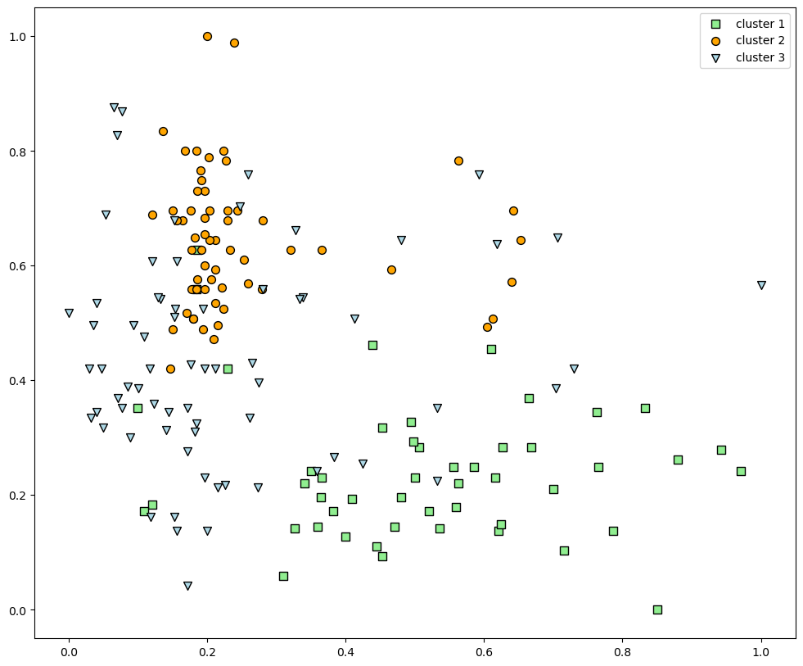

Hierarchical clustering
#Data Scaling
data_scaled = normalize(df)
data_scaled = pd.DataFrame(data_scaled , columns = df.columns)
data_scaled.head()
Wine Alcohol Malic.acid Ash Acl Mg Phenols \
0 0.000932 0.013264 0.001594 0.002265 0.014542 0.118383 0.002610
1 0.000948 0.012513 0.001687 0.002029 0.010617 0.094794 0.002512
2 0.000841 0.011063 0.001984 0.002245 0.015636 0.084906 0.002354
3 0.000674 0.009680 0.001314 0.001684 0.011317 0.076119 0.002593
4 0.001343 0.017775 0.003477 0.003853 0.028193 0.158417 0.003759
Flavanoids Nonflavanoid.phenols Proanth Color.int Hue OD \
0 0.002852 0.000261 0.002135 0.005257 0.000969 0.003654
1 0.002616 0.000246 0.001213 0.004152 0.000995 0.003223
2 0.002724 0.000252 0.002362 0.004775 0.000866 0.002665
3 0.002351 0.000162 0.001468 0.005254 0.000579 0.002324
4 0.003611 0.000524 0.002443 0.005800 0.001396 0.003934
Proline
0 0.992738
1 0.995336
2 0.996175
3 0.996961
4 0.986752
#Building dendegram to determine the optimal no of clusters
plt.figure(figsize=(10, 7))
plt.title("Dendograms")
dend = shc.dendrogram(shc.linkage(df, method='ward'))
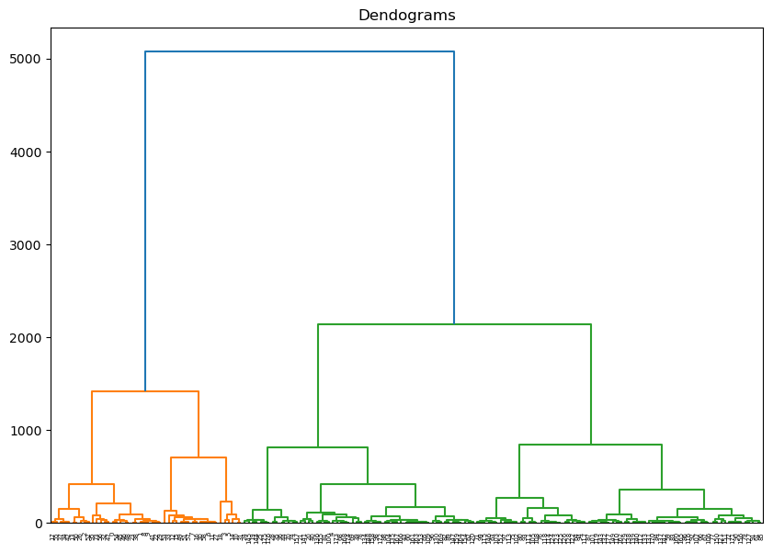
plt.figure(figsize = (10,7))
plt.title("Dendrograms")
dend = shc.dendrogram(shc.linkage(data_scaled , method = 'ward'))
plt.axhline(y = 6.4 , color = 'r',linestyle = '--')
<matplotlib.lines.Line2D at 0x281a93e6a10>
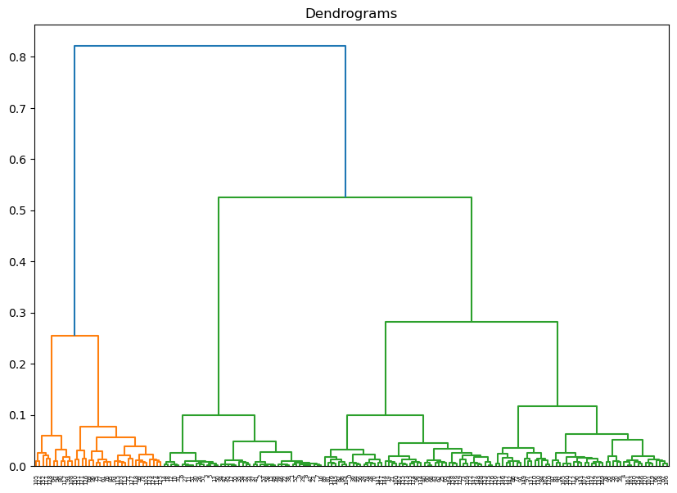
#forming three clusters
cluster = AgglomerativeClustering(n_clusters = 3 , affinity = 'euclidean')
cluster.fit_predict(data_scaled)
array([0, 2, 2, 2, 0, 2, 2, 2, 2, 2, 2, 2, 2, 2, 2, 2, 2, 2, 2, 0, 0, 0,
2, 2, 0, 0, 2, 2, 0, 2, 2, 2, 2, 2, 2, 2, 0, 2, 2, 0, 0, 2, 2, 0,
0, 2, 2, 2, 2, 2, 2, 2, 2, 2, 2, 2, 0, 2, 2, 0, 0, 1, 0, 1, 1, 0,
0, 0, 0, 1, 0, 1, 0, 0, 0, 1, 1, 1, 0, 1, 1, 0, 0, 0, 0, 1, 0, 0,
0, 0, 0, 0, 0, 1, 1, 0, 1, 0, 0, 1, 0, 0, 1, 1, 0, 1, 0, 0, 1, 0,
0, 1, 0, 1, 1, 1, 0, 1, 1, 0, 0, 1, 1, 1, 1, 1, 1, 1, 1, 0, 0, 0,
0, 0, 0, 0, 0, 0, 0, 0, 0, 0, 0, 0, 0, 0, 0, 0, 0, 0, 1, 1, 1, 0,
0, 0, 0, 0, 0, 0, 0, 0, 0, 0, 0, 0, 0, 0, 0, 0, 0, 0, 0, 0, 0, 0,
0, 0], dtype=int64)

Visualizing the clusters
plt.figure(figsize = (10,7))
plt.scatter(data_scaled['Alcohol'] , data_scaled['Acl'])
<matplotlib.collections.PathCollection at 0x281a96bd960>
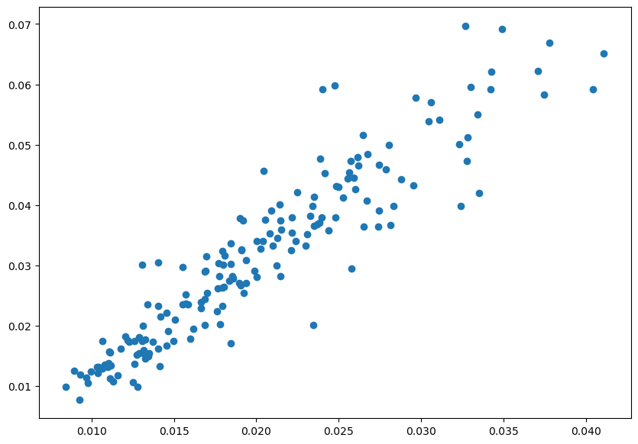

DBSCAN Algorithm Clustering
#Compute data proximity from each other using Nearest Neighbours
neighb = NearestNeighbors(n_neighbors=2)
nbrs=neighb.fit(x)
distances, indices=nbrs.kneighbors(x)
plt.figure(figsize = (8,5))
distances = np.sort(distances, axis = 0)
distances = distances[:, 1]
plt.plot(distances)
plt.show()
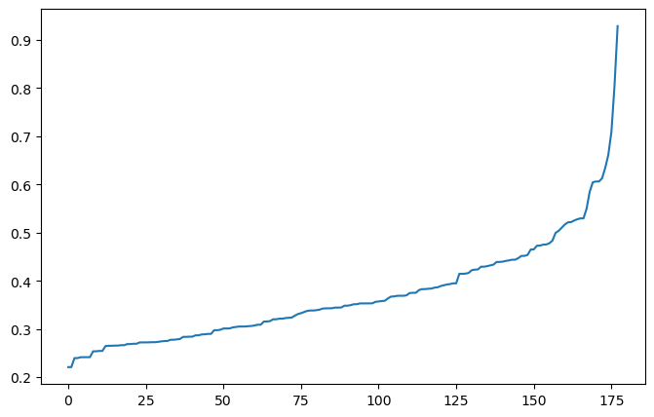
#cluster the data into three clusters
dbscan = DBSCAN(eps = 7, min_samples = 4).fit(x) # fitting the model
labels = dbscan.labels_

Plotting the clusters
plt.figure(figsize = (10,7))
plt.scatter(x[:, 0], x[:,1], c = labels, cmap= "plasma")
plt.show()
